2nd Lt David Crow

ENG/20M

CSCE 531 Final Exam



By enumeration, the cardinality of the total sample space is $\left|S\right|=$ $\left|\left\{11, 12,13,14,15,16,22,23,24,25,26,33,34,35,36,44,45,46,55,56,66\right\}\right|=21$.

The cardinality of the event space is $\left|E\right|=\left|\left\{12,24,36\right\}\right|=3$.

Thus, the probability of the event is $P\left(E\right)=\frac{\left|E\right|}{\left|S\right|}=\frac{3}{21}$, which does not correspond to any of the above answers.

Because English can be ambiguous, I’m not totally clear on the meaning of the phrase “differ by a factor of two.” However, there are still $21$ events in the sample space, and $21$ does not reduce to $11$. We can reduce $\frac{7}{21}$, $\frac{14}{21}$, and $\frac{21}{21}$ to $\frac{1}{3}$, $\frac{2}{3}$, and $\frac{3}{3}$, respectively, and these are equivalent to $\frac{12}{36}$, $\frac{24}{36}$, and $\frac{36}{36}$, respectively. This all implies that, even if I misunderstood $E$, none of the above answers can be correct because $\left|S\right|=21$.



Because $6+7=13$, the statement “find the probability of exactly six 0s” can be restated as “find the probability of exactly seven 1s;” in other words, they are equivalent, and thus their probabilities are necessarily equal. The answer is Choice B.



Here’s the sample space: $S=\{HH,HT,TH,TT\}$.

Thus, $P\left(E_{1}\right)=\frac{2}{4}=\frac{1}{2}$, $P\left(E_{2}\right)=\frac{2}{4}=\frac{1}{2}$, and $P\left(E_{3}\right)=\frac{2}{4}=\frac{1}{2}$. Furthermore, $P\left(E_{1}\right)P\left(E_{2}\right)=\frac{1}{2}⋅\frac{1}{2}=\frac{1}{4}$, $P\left(E_{1}\right)P\left(E_{3}\right)=\frac{1}{2}⋅\frac{1}{2}=\frac{1}{4}$, and $P\left(E_{2}\right)P\left(E_{3}\right)=\frac{1}{2}⋅\frac{1}{2}=\frac{1}{4}$. Finally, $P\left(E_{1}∩E_{2}\right)=\frac{1}{4}$, $P\left(E_{1}∩E_{3}\right)=\frac{1}{4}$, and $P\left(E_{2}∩E_{3}\right)=0$.

Because $P(E_{1}∩E_{2})=\frac{1}{4}=P\left(E_{1}\right)P(E_{2})$, $E_{1}$ and $E_{2}$ are independent.

Because $P(E_{1}∩E_{3})=\frac{1}{4}=P\left(E_{1}\right)P(E_{3})$, $E_{1}$ and $E_{3}$ are independent.

Because $P\left(E_{2}∩E_{3}\right)=0≠\frac{1}{4}=P(E_{2})P(E_{3})$, $E_{2}$ and $E_{3}$ are not independent.

Thus, the answer is Choice B.



The number of devices infected in a given week is the total number of devices infected one week ago plus the number of devices newly infected two weeks ago.

Alternatively, we can compute the number of devices infected in the first few weeks:

Week 1: 1

Week 2: 1

Week 3: 3

Week 4: 5

Week 6: 11

Week 7: 21

Week 8: 43

In both cases, we see that the answer is Choice D.



There are $6^{3}=216$ events in the sample space. Of these, those that do not satisfy any of the three events are of the form $xyx$, where $2≤x≤6$, $1≤y≤6$, and $x≠y$. We thus have $5*5=25$ events that do not satisfy one of $E_{1}$, $E_{2}$, or $E_{3}$; this implies that there are $216-25=191$ events that do satisfy one of the three properties. The probability of at least one of the events occurring is $P\left(E_{1}∪E_{2}∪E_{3}\right)=\frac{191}{216}$.

Alternatively, note that $P\left(E_{1}\right)=\frac{6⋅6}{216}=\frac{36}{216}$, which is already greater than Choices A, B, or C.

In both cases, the correct answer is Choice D.





Because all elements on the diagonal must be $1$ if the matrix is reflexive, the answer is necessarily Choice B.



A relation is symmetric if and only if the values reflect over the diagonal. Thus, $w$ must equal $1$; this implies the correct answer is Choice A.



A relation is antisymmetric if, for all $a$ and $b$, $\left(a,b\right)∈R∧\left(b,a\right)∈R→a=b$. Thus, for this relation to be antisymmetric, $y=1$, $z=0$, and $w=0$. This implies the correct answer is Choice A.



Because $(2,3)$ and $(3,1)$ are already in the relation, $(2,1)$ must also be in the relation for this relation to be transitive. This implies $y=1$, so we can rule out Choices C and D.

If $w=1$, then we add $(3,2)$ to the relation. Because $(2,3)$ is already in the relation, $(3,3)$ must also be in the relation for it to be transitive. In other words, $w=1→x=1$.

Finally, the relation can still be transitive if $(3,3)$ is in the relation and $(3,2)$ is not. This implies $w$ and $x$ are not required to be equal. Thus, the correct answer is Choice B.



To ensure the relation is symmetric, $w$ must equal $1$. To ensure the relation is reflexive, $x$ must equal $1$. Thus, if the relation is an equivalence relation, $x=1=w$. If $y=1$, the relation is not symmetric. However, if $y=0$, the relation is not transitive. The relation is thus an equivalence relation if and only if $y=0=1$. The answer is Choice D.



The sets in Choice A are not a partition because $x=0$ is in the set where $k=-1$ and in the set where $k=1$. Thus, the sets are not disjoint.

The sets in Choice B are not a partition because $x=0.5$ is in the set where $k=1$ and in the set where $k=0$. Thus, the sets are not disjoint.

The sets in Choice C are a partition. There is no value for $x∈R$ such that $\left|x-k\right|<\frac{1}{2}$ and $\left|x-j\right|<\frac{1}{2}$ for some $j,k∈Z$. Thus, the sets are disjoint and the union over all sets is the set of real numbers ($R$).

The answer is Choice C.



The reflexive closure is $R∪\{\left(a,b\right):a=b\}$, which corresponds to Choice B.



$R$ contains, among others, $\left(2,3\right)$, $\left(3,4\right)$, and $\left(3,8\right)$ but not $(2,4)$ or $(2,8)$. It’s clear that the transitive closure of $R$ is $R∪\left\{\left(a,b\right):a divides b\right\}$, which is equivalent to $\{\left(a,b\right):\gcd\left(a,b\right)=1∨a divides b\}$. Although this is not one of the above answers, it is closest to Choice B.



The relation in Choice D is not transitive. If $g\left(i\right)=0$ for all $i$, $f\left(i\right)≠0$ for all $i$, and $h\left(i\right)≠0$ for all $i$, $\sum_{0}^{n-1}{f\left(i\right)g\left(i\right)=0=\sum_{0}^{n-1}{g\left(i\right)h(i)}}$, but it is not necessarily true that $\sum_{0}^{n-1}{f\left(i\right)h\left(i\right)=0}$. Because the relation is not transitive, it is not an equivalence relation. Thus, the correct answer is Choice D.



By Euler’s Formula, $r=e-v+2=\frac{10⋅13}{2}-13+2=54$. Thus, the answer is Choice A.



We can deal four consecutive aces in $4!$ different ways. If we now treat the four aces as one card, there are $\left(52-4+1\right)!=49!$ different ways to deal all cards. There are thus $49!⋅4!$ ways to deal four consecutive aces. This gives a probability of $\frac{49!⋅4!}{52!}$.



Let’s assume the question asks us to find the expected number of rolls to see two $6$ s in a row. In this new problem, if we let $E_{6}$ be the expected number of rolls before we see two $6$ s in a row, there are three possible cases:

Case 1: We roll something other than $6$ in the first roll. We thus need $E_{6}+1$ rolls because we’ve rolled once and we’re back to where we started.

Case 2: We roll a $6$ in the first roll and something other than $6$ in the second roll. We thus need $E_{6}+2$ rolls because we’ve rolled twice and we’re back to where we started.

Case 3: We roll consecutive $6$ s in the first two rolls. Thus, we need $2$ rolls because we’ve already satisfied the problem.

Case 1 has a probability of $\frac{5}{6}⋅(E_{6}+1)$, Case 2 has a probability of $\frac{1}{6}⋅\frac{5}{6}⋅(E_{6}+2)$, and Case 3 has a probability of $\frac{1}{6}⋅\frac{1}{6}$. If we sum over all cases, we see that the expected number of rolls is $E_{6}=\left(\frac{5}{6}⋅E_{6}+\frac{5}{6}\right)+\left(\frac{5}{36}⋅E_{6}+\frac{10}{36}\right)+\left(\frac{1}{36}\right)=\frac{35}{36}⋅E_{6}+\frac{41}{36}$. If we rearrange, we see that $\frac{1}{36}⋅E_{6}=\frac{41}{36}⇒E_{6}=41$.

We expect $41$ rolls before we see two $6$ s in a row, so we expect $\frac{41}{6}=6.8\overline{3}$ rolls before we see two of the same number in a row.



The characteristic equation for the linear homogenous equation is $r^{2}=r+2$. This gives $r^{2}-r-2=0$, and the roots are thus $r=2$ and $r=-1$. We now see that

$a_{n}^{(h)}=α_{1}{\left(2\right)}^{n}+α_{2}{\left(-1\right)}^{n}$.

A reasonable trial solution is $p_{n}=cn+d$. Our given recurrence relation $a_{n}=a_{n-1}+2a_{n-2}+2n$ then becomes $cn+d=\left(c\left(n-1\right)+d\right)+2\left(c\left(n-2\right)+d\right)-2n$

$=cn-c+d+2cn-4c+2d-2n=3cn-5c+3d-2n$.

Combining like terms here gives $0=2cn-5c+2d-2n=n\left(2c-2\right)+(2d-5c)$. It follows that $cn+d$ is a solution if and only if $2c-2=0$ and $2d-5c=0$. We now see that $c=1$ and $d=\frac{5}{2}$. Consequently, $a_{n}^{\left(p\right)}=n+\frac{5}{2}$ is a particular solution.

All solutions are of the general form $a_{n}=a_{n}^{\left(p\right)}+a_{n}^{\left(h\right)}=n+\frac{5}{2}+α_{1}{\left(2\right)}^{n}+α_{2}{\left(-1\right)}^{n}$. In plugging in our initial conditions, we see that $a_{0}=5=0+\frac{5}{2}+α_{1}+α_{2}$ and that

$a_{1}=7=1+\frac{5}{2}+2α_{1}-α_{2}$. In solving, $α_{1}=\frac{5}{2}-α_{2}$ and $\frac{7}{2}=2\left(\frac{5}{2}-α_{2}\right)-α_{2}$. Thus, we see that $\frac{7}{2}=5-3α_{2}⇒α_{2}=\frac{1}{2}$ and $α_{1}=\frac{5}{2}-\frac{1}{2}=\frac{4}{2}=2$.

We see now that our solution is $a_{n}=n+\frac{5}{2}+2⋅{\left(2\right)}^{n}+\frac{1}{2}⋅{\left(-1\right)}^{n}$.



The below graphs represent $G$ and $\overline{G}$ . I am fairly certain I labeled the vertices correctly, but the fact that the graphs are self-complementary should be self-evident. I sketched out (on paper) quite a few different graphs before finding these, but I did realize early on that a pentagon/pentagram should be a subgraph of / .

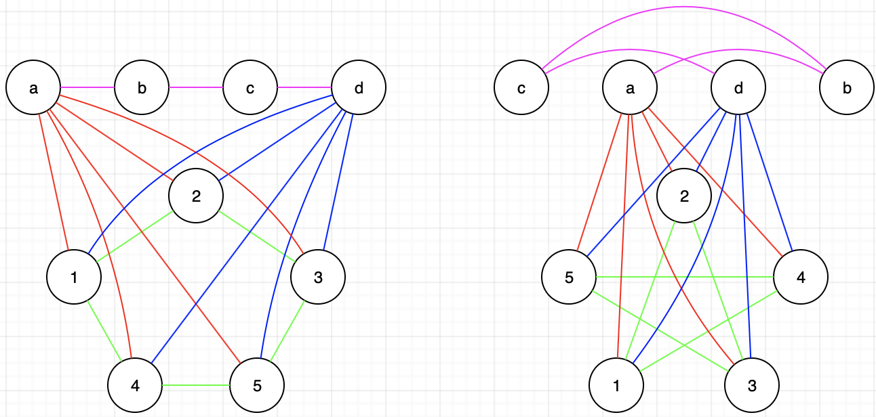



Basis step: $n=2$

In a connected graph with four vertices $00$, $01$, $10$, and $11$, removing one vertex leaves three vertices, and each of these three vertices is still connected to at least one other vertex. Thus, $Q_{2}$ has no cut vertices.

Inductive hypothesis:

An n-dimensional hypercube $Q_{n}$ has no cut vertices.

Inductive step:

We know that $Q_{n+1}$ has $2^{n+1}=2⋅2^{n}$ vertices. Each new vertex $v∈V_{new}$ is connected to $1$ vertex in $Q_{n}$ and $n-1$ vertices in $Q_{n+1}$. This implies that there is more than one edge from $Q_{n}$ to $V_{new}$, and it also implies that there is more than one edge from each $v∈V_{new}$ to each $v^{'}∈V_{new}$. We can remove vertex from $Q_{n+1}$ and still have at least one edge to each remaining node in $Q_{n+1}$. Thus, there are no cut vertices in $Q_{n+1}$.

By the principle of mathematical induction, the theorem is proved.